The Paradox of Green Identity in Social Media Thrift Culture
Anisa Rizki Sabrina¹, Berliana Rohmah Nirmala², Fairuza Arindra³, dan Ratna Triwurian Danu⁴

^{1,2,3,4} Universitas Negeri Malang, Kota Malang, Indonesia
ABSTRACT
Thrift culture has grown in popularity among Gen Z on platforms like TikTok and Instagram, often portrayed as an ethical and eco-friendly alternative to fast fashion. This study critically investigates how digital thrift content simultaneously promotes sustainability while encouraging new forms of consumption. Using a netnographic approach, 40 social media posts were analyzed between April and June 2025, focusing on hashtags such as #thriftinghaul and #sustainablefashion. The research draws on symbolic interactionism and digital self-presentation theory to examine how sustainability is represented and interpreted. Findings reveal four key patterns: thrift is used as a digital identity marker; green values are often aestheticized; excessive purchases are morally justified as secondhand; and algorithmic visibility amplifies content that normalizes high-volume consumption. These patterns collectively constitute what this study terms the Digital Thrift–Sustainability Paradox—a condition in which sustainability discourse is simultaneously invoked and undermined within the same digital practice. Rather than challenging fast fashion, thrifting online may reproduce similar consumerist logics under a sustainable label. This study contributes to debates in digital communication and sustainability by highlighting how social media environments shape, reframe, and sometimes distort ecological values. It calls for a more critical lens in environmental messaging—one that recognizes the influence of digital aesthetics, platform dynamics, and symbolic consumption. In doing so, the study encourages deeper reflection on authenticity in sustainability communication.
Keywords: digital consumption; green identity; thrift culture; toxic spending; sustainability.
ABSTRAK
Budaya thrift semakin populer di kalangan Generasi Z pada platform seperti TikTok dan Instagram, serta kerap direpresentasikan sebagai alternatif yang etis dan ramah lingkungan terhadap fast fashion. Penelitian ini secara kritis mengkaji bagaimana konten thrift digital secara simultan mempromosikan keberlanjutan sekaligus mendorong bentuk-bentuk konsumsi baru. Dengan menggunakan pendekatan netnografi, sebanyak 40 unggahan media sosial dianalisis dalam rentang waktu April hingga Juni 2025, dengan fokus pada tagar seperti #thriftinghaul dan #sustainablefashion. Penelitian ini berlandaskan teori interaksionisme simbolik dan teori presentasi diri digital untuk menelaah bagaimana keberlanjutan direpresentasikan dan dimaknai dalam ruang digital. Hasil penelitian mengungkapkan empat pola utama, yaitu: praktik thrift digunakan sebagai penanda identitas digital; nilai-nilai hijau kerap diaestetisasi; pembelian berlebihan dibenarkan secara moral karena bersifat barang bekas; serta visibilitas algoritmik memperkuat sirkulasi konten yang menormalisasi konsumsi dalam jumlah besar. Pola-pola ini secara kolektif membentuk apa yang dalam studi ini disebut sebagai Digital Thrift–Sustainability Paradox—suatu kondisi di mana wacana keberlanjutan sekaligus dihadirkan dan dilemahkan dalam praktik digital yang sama. Alih-alih menantang logika fast fashion, praktik thrifting di ruang daring justru berpotensi mereproduksi pola konsumsi serupa dengan label keberlanjutan. Penelitian ini berkontribusi pada perdebatan dalam kajian komunikasi digital dan keberlanjutan dengan menyoroti bagaimana lingkungan media sosial membentuk, membingkai ulang, dan dalam beberapa konteks mendistorsi nilai-nilai ekologis. Studi ini menekankan pentingnya pendekatan yang lebih kritis dalam komunikasi lingkungan, khususnya dengan mempertimbangkan pengaruh estetika digital, dinamika platform, dan konsumsi simbolik. Dengan demikian, penelitian ini mendorong refleksi yang lebih mendalam mengenai autentisitas dalam komunikasi keberlanjutan.
Kata kunci: konsumsi digital; identitas hijau; budaya thrifting; perilaku konsumsi yang tidak sehat; keberlanjutan.

INTRODUCTION
Sustainable lifestyle communication has become a central concern in contemporary discussions of climate change and consumer culture. Amid growing public awareness of the environmental impacts of the fashion industry, alternative consumption practices such as thrift culture have gained moral legitimacy as more ethical and environmentally friendly options compared to fast fashion. Young people, particularly Generation Z, are frequently positioned as key agents in this transformation due to their high levels of digital literacy, environmental awareness, and socio-political engagement (Francis & Hoefel, 2018; Fromm & Garton, 2013). Social media platforms such as TikTok and Instagram have consequently emerged as primary arenas in which sustainability values are not only communicated but also performed as part of everyday lifestyle and identity construction.
However, the dominance of social media as a space for identity formation and lifestyle exhibition introduces more complex dynamics. Rather than merely reflecting ethical consumption practices, sustainability representations on social media are often shaped by visual aesthetics, personal narratives, and algorithmic visibility — dynamics that are characteristic of platform capitalism, in which content circulation is governed by engagement metrics and attention-driven infrastructures (van Dijck et al., 2018). This condition raises a critical question regarding whether sustainability narratives circulating online genuinely correspond to changes in consumption behavior or instead reproduce existing consumerist logics through symbolic and aestheticized forms.
Previous studies have examined various dimensions of ethical consumption and digital culture. Connolly and Prothero (2008) argue that green consumption is frequently framed through moral narratives that are susceptible to co-optation by market logics. Lundblad and Davies (2016) introduced the concept of the ecological fashion paradox to describe the tension between sustainability values and the accelerated dynamics of the fashion industry. In the context of digital media, Abidin (2018) and Banet-Weiser (2018) demonstrate how practices of self-branding and performativity shape young people’s ethical and cultural expressions on social media. These studies provide important theoretical foundations for understanding how morality, identity, and consumption intersect within digital environments.
More recent scholarship has begun to link thrift culture with sustainability narratives and digital storytelling practices. Monteiro, et al (2025) conceptualize thrifting as a digital narrative space that enables consumers to articulate alternatives to mainstream consumption. Zhang and Zhao (2025) further show how sustainability aesthetics among Generation Z are constructed through visual practices and storytelling within specific cultural contexts. Nevertheless, much of this literature remains centered on Western or East Asian settings and tends to frame thrifting primarily as a form of resistance to overconsumption, paying limited attention to how platform infrastructures and algorithmic systems shape both the intensity and meaning of consumption.
In the Indonesian context, academic inquiry into social media–driven thrift culture remains relatively limited. This gap is notable given that Indonesia is among the world's largest social media markets, with TikTok and Instagram reporting exceptionally high engagement rates among Gen Z users in the country (DataReportal, 2025). Beyond platform reach, Indonesia presents a culturally and economically distinctive context for thrift culture. The practice of secondhand trade has deep historical roots in the country, with markets such as Pasar Senen in Jakarta dating back to 1733 (Enciety Business Consult, 2025). Today, conservative estimates suggest that thrift markets in major Indonesian cities generate daily transactions worth between IDR 5 billion and IDR 10 billion (Enciety Business Consult, 2025), indicating that thrifting has evolved from a marginal economic activity into a significant cultural and commercial phenomenon — one that is now increasingly mediated through digital platforms. As a Global South nation with a rapidly expanding digital economy, Indonesia offers a critical vantage point for examining how sustainability narratives travel across cultural and infrastructural settings that differ substantially from the Western contexts that dominate existing literature. The popularity of content formats such as thrift hauls, live thrift sessions, and outfit transformations on TikTok and Instagram suggests that thrifting functions not only as an alternative consumption practice but also as entertainment, a status symbol, and a source of social capital. At this intersection, a tension emerges between claims of sustainability and the increasing normalization of high-volume consumption.
To date, there remains a significant research gap concerning how thrift culture in Indonesian social media operates simultaneously as a sustainability practice and a form of morally legitimized symbolic consumption. Existing studies have not sufficiently addressed the paradox between green narratives and the normalization of excessive purchasing within algorithmically driven platforms, particularly among Generation Z in Global South contexts. Moreover, limited attention has been given to integrating analyses of visual representation, user interaction, and platform visibility logics to explain how sustainability meanings are produced and negotiated in everyday social media practices.
Responding to this gap, the present study offers a novel contribution by examining thrift culture as a paradoxical form of digital communication: one that promotes green identity while potentially reproducing consumerist logics through aestheticization and moral justification. Employing a netnographic approach, this research goes beyond behavioral analysis to investigate the symbolic and algorithmic infrastructures shaping the circulation of sustainability meanings on social media. By integrating symbolic interactionism, digital self-presentation theory, and the concepts of virtue signaling and moral licensing, this study provides a comprehensive framework for understanding how ecological identities are constructed and performed in algorithmically mediated spaces.
Accordingly, this study aims to critically examine how thrift culture is represented and interpreted by Generation Z on social media, and how sustainability narratives operate in relation to consumption practices, digital aesthetics, and platform logics. By situating the analysis within the Indonesian context, this research seeks to contribute to scholarship on digital communication and sustainability while offering theoretical insights into the paradoxes of sustainable consumption in contemporary digital culture.

METHOD
This study is designed as a qualitative research employing a netnographic approach, a method developed by Kozinets (2020), to examine the social, cultural, and symbolic dimensions of digital thrift culture on social media platforms. Netnography is particularly appropriate for this study as it enables the systematic observation of naturally occurring online interactions, allowing researchers to capture meaning-making processes, identity performances, and cultural values embedded within digital communities.
The research adopts an exploratory and interpretive design, focusing on how thrift culture, green awareness, and ethical consumption are represented and negotiated through user-generated content. Rather than treating social media texts as isolated artifacts, this study situates digital content within its interactive and symbolic context by examining visual representations, captions, user interactions, and engagement patterns.
Data collection was conducted on two major social media platforms, TikTok and Instagram, selected due to their prominence among Generation Z and their emphasis on visual and performative content. On TikTok, the research mapped digital communities engaging with hashtags such as #thrifthaul, #thriftchallenge, and #thriftindonesia. On Instagram, data were drawn from posts associated with hashtags including #OOTDthrift, #sustainablefashion, #greenliving, #thriftID, #thrift, #thriftfinds, #thrifting, #thriftstore, #thriftedfashion, and #thriftwithme. The data collection period spanned from April to June 2025.
A total of 40 digital content samples were selected through purposive sampling based on the following inclusion criteria: (1) content featured hashtags relevant to thrift consumption and sustainability discourse, including #thriftinghaul, #OOTDthrift, #thriftchallenge, #sustainablefashion, and #greenliving; (2) content took the form of visual media, either photo or video; (3) the account was publicly accessible without authentication; and (4) content reflected themes of thrift consumption, green awareness, and lifestyle representation characteristic of Generation Z digital culture, as identifiable through visual aesthetics and narrative framing such as short-form captions. No additional exclusion criteria were applied beyond the above inclusion criteria. This sample size is considered adequate for in-depth thematic analysis within qualitative netnographic research, consistent with Kozinets's (2020) argument that data sufficiency in netnography is determined by the depth and information richness of the material obtained rather than by quantity alone.
Consistent with ethical netnographic practice, the researcher engaged in passive participation, combining observational immersion with non-intervention in online interactions. Only publicly accessible content was analyzed, and no direct engagement with users occurred during the data collection process. This approach aligns with established ethical guidelines for digital research and prioritizes user privacy and contextual integrity.
To capture the complexity of digital thrift practices, three complementary data collection techniques were employed. First, non-obtrusive participant observation was conducted through systematic examination of video content, captions, comments, interaction patterns, and symbolic markers such as emojis and hashtags. Second, digital documentation was undertaken to archive visual and textual materials for iterative analysis. Third, field notes were maintained throughout the research process to record emerging patterns, dominant narratives, and reflexive observations related to representations of sustainability and consumption.
Data analysis was carried out through thematic content analysis integrated with netnographic interpretation. The analytical process involved several stages. Initially, the collected data were subjected to open coding to identify recurring meanings, symbols, and interactional patterns. These codes were then grouped into broader thematic categories based on similarities in visual style, narrative structure, and discursive emphasis. Themes such as green identity, aestheticized sustainability, digital flexing, and moral justification of consumption emerged through this iterative process.
To enhance analytical rigor, data reduction was applied by focusing on the most representative and information-rich content, while cross-checking emerging themes across platforms and content formats. The final stage of analysis involved interpretive synthesis, linking empirical patterns to relevant theoretical frameworks, including symbolic interactionism, digital self-presentation theory, and concepts of moral licensing and virtue signaling. This process enabled the construction of interpretive narratives that elucidate the paradoxes, values, and symbolic meanings surrounding digital thrift culture and green consciousness among Generation Z.

RESULT AND DISCUSSION
This study identified 40 digital content samples collected from April to June 2025 across two social media platforms—TikTok and Instagram—featuring posts that utilize hashtags such as #thriftinghaul, #OOTDthrift, #thriftchallenge, #sustainablefashion, and #greenliving. The samples were selected based on their relevance to themes of thrift consumption, green awareness, and lifestyle representation among Generation Z users. The analysis focused on recurring visual patterns, narrative framing, interaction formats, and platform-specific affordances that characterize digital thrift practices.

- Thrift as Digital Identity Marker
Figure 1. Example of haul sequences.
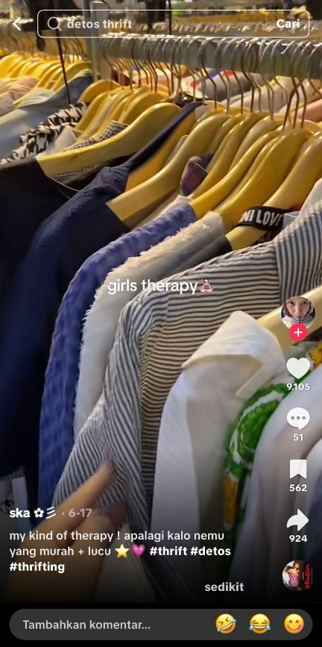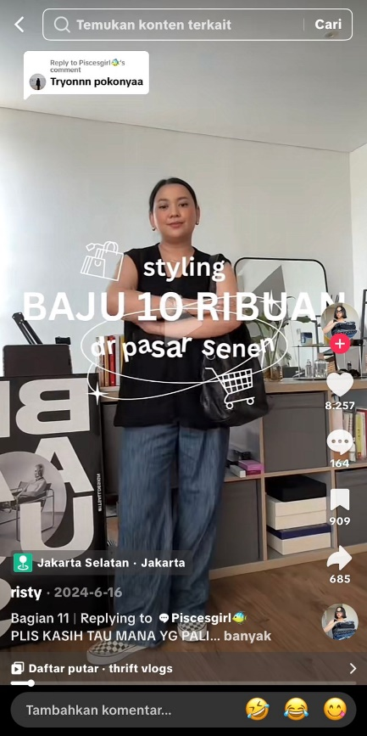
On TikTok, thrift-related content frequently adopts a storytelling format involving before–after transitions and haul sequences. A recurring pattern shows users displaying a large number of clothing items, typically ranging from 5 to 10 pieces per video, accompanied by budget-oriented captions such as “thrift haul only 10k,” “rich look, cheap price,” or “my kind of therapy—especially when I find something cheap and cute.” These videos are commonly produced using cinematic transitions, vintage-inspired aesthetics, and neutral or earth-tone filters.
Beyond the surface presentation, repeated visual motifs—such as curated outfit displays, consistent editing styles, and branded thrift captions—position thrift practices as recognizable markers of personal style and self-presentation. Across both TikTok and Instagram, users repeatedly frame thrifting as a reflection of knowledgeability, trend awareness, and ethical sensitivity, indicating that thrift content functions as a visible signifier of eco-conscious lifestyle positioning within digital environments.

- Algorithmic Visibility and Real-Time Thrift Practices
Figure 2. Example of Live Thrift.
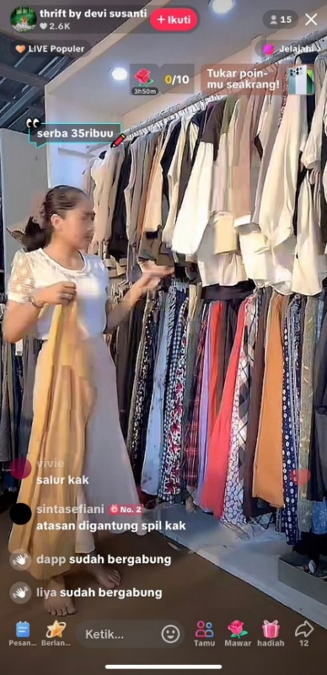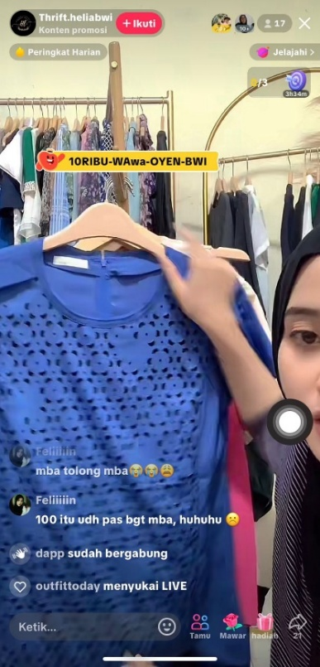
Variations in thrift practices are evident across different content formats, particularly between haul videos and live thrift sessions on TikTok. Haul formats emphasize immediacy, quantity, and price, with creators highlighting the number of items acquired as an indicator of successful thrifting. In contrast, live thrift sessions foreground real-time interaction, bargaining, and urgency, encouraging viewers to participate actively in purchasing decisions as the content unfolds.
Several TikTok videos, including those categorized as “Live Thrift,” involved real-time sales and bargaining, indicating active user engagement in secondhand commerce. On average, these livestreams attracted between 50 to 500 viewers, with the comment section serving as a dynamic space for interaction between sellers and potential buyers. Typical comments include questions and offers such as “What’s the chest circumference of the shirt with the bear print?”, “Can you show the top that’s hanging, sis?”, “100k is already a good deal, miss, huhuhu,” “How much is item number 8, bro?”, and “They’re getting bolder with their bargaining.” These interactions demonstrate how secondhand consumption is embedded within performative, time-sensitive exchanges shaped by platform affordances.
Patterns of engagement further show that content featuring frequent uploads, large hauls, trending audio, and visually optimized formats consistently attracted higher interaction. As a result, thrift practices appeared repeatedly associated with cycles of posting, visibility, and audience engagement within platform-driven environments.

- Sustainability Narratives and Environmental Concerns
Figure 3. Example of environmental concerns.
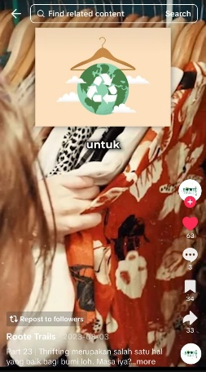
Content thematizing environmental concerns appeared in at least 10 TikTok uploads. Phrases such as “thrifting saves the planet” or “secondhand is sustainable” were either spoken or embedded in captions like “thrifting is supposed to be good for the planet—really?”. One illustrative example includes the on-screen explanation: "Besides being affordable, thrifting also helps protect the environment from harm. The fashion industry accounts for 10% of greenhouse gas emissions, 4% of global carbon emissions, and 20% of wastewater—posing serious threats to our planet. Thrifting offers a sustainable solution by reducing the demand for new production. So, who’s with me in saving the Earth?”
On Instagram, similar narratives appeared through stylized outfit montages tagged with #OOTDthrift and #sustainablefashion. Approximately 80% of sampled Instagram reels incorporated music that was also trending on TikTok, indicating cross-platform circulation of sustainability-themed thrift content. These posts frequently presented secondhand fashion as an affordable and environmentally conscious choice, reinforcing sustainability as a recurring narrative element within thrift-related communication.

- Aestheticization of Thrift and Style Transformation
Figure 4. Thrift-based style transformations.

Instagram-based content, particularly OOTD thrift reels and style transformation posts, emphasized visual coherence and personal branding. Thrifted outfits were presented through curated color palettes, coordinated styling, and trend-driven editing formats. Content such as “what I thrifted versus how I styled it” highlighted transformation as a central narrative device, positioning thrift as a visually appealing and intentional lifestyle practice.
Thumbnail text overlays and captions often employed humor and irony, including phrases such as “When your brain works better while thrifting than when you’re studying,” “It’s like this: you’ve been saving hard to buy shoes for a concert, then suddenly score an original pair for just around 100k,” or “Getting called out for wearing fakes by someone who’s never bought the original.” These elements functioned as semiotic cues that combined self-commentary with aesthetic display, embedding thrift practices within broader patterns of digital storytelling.

- Emotional Gratification and Self-Reward Narratives
Figure 5. Example of emotional gratification.
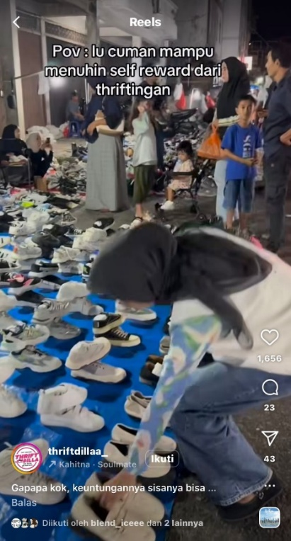
Another notable pattern concerns the affective dimensions of thrift practices. Across both platforms, thrifting is frequently framed as a form of emotional gratification and self-reward. Captions and spoken narratives emphasize pleasure, excitement, and relief associated with finding inexpensive items. Captions such as “You want to fulfill your self-reward just by thrifting” illustrate how secondhand shopping is associated with self-care and emotional validation. This framing situates thrift purchasing as a source of personal gratification rather than solely as an ethical or economic decision.
A recurrent theme involved the normalization of frequent secondhand shopping. Although thrifting was often described as sustainable, video content emphasized affordability and purchasing volume. One representative caption stated, “Torn between saving for a new one or grabbing these cheap thrift shoes I don’t really need… oh well, better take them before they haunt me.” Such narratives show how low prices and secondhand status accompany repeated purchasing practices within everyday routines.
- Platform-Specific Intensification of Thrift Practices
Beyond shared patterns across platforms, the analysis also reveals platform-specific intensifications in how thrift practices are articulated and circulated. TikTok content tends to privilege immediacy, speed, and volume, with short-form videos emphasizing rapid transitions, spontaneous discovery, and large quantities of items acquired within a single session. The fast-paced nature of TikTok encourages creators to foreground excitement and novelty, framing thrifting as an impulsive and emotionally charged activity that unfolds in real time. This temporal compression reinforces the perception of thrifting as an event-driven practice rather than a reflective consumption choice.
In contrast, Instagram-based thrift content exhibits a slower and more curated rhythm. OOTD thrift posts and green lifestyle reels emphasize coherence, aesthetic continuity, and personal branding over time. While purchasing volume is less explicitly highlighted, consumption remains central through the repeated presentation of different outfits, styling combinations, and thrift “finds.” This suggests that thrift practices on Instagram are embedded within longer-term identity projects, where sustainability is aligned with lifestyle consistency and visual refinement.
Despite these differences, both platforms converge in their reliance on repetition and visibility. Content creators on TikTok and Instagram frequently reuse similar narrative formats, hashtags, and visual cues, indicating the presence of recognizable thrift content templates. These templates facilitate audience recognition and algorithmic circulation, while simultaneously shaping expectations about what thrift content should look like. As a result, thrift practices are not only influenced by individual preferences but also by platform-specific conventions that guide content production and audience engagement.
This cross-platform comparison highlights how thrift consumption is shaped by distinct yet complementary digital environments. While TikTok amplifies thrift as an affective and transactional spectacle, Instagram frames thrift as a curated lifestyle narrative. Together, these platforms contribute to the normalization of secondhand consumption as a visible, repeatable, and socially validated practice within Gen Z digital culture.
- Summary of Empirical Patterns
Table 1. Visual Summary of Netnographic Data
Platform | Content Type | Common Narratives | Dominant Visual/Aesthetic Styles | Popular Hashtags | Interaction Patterns
TikTok | Thrift Haul, Thrift Challenge | “Affordable yet stylish”, “Green living”, “Under 100k” | Earth tones, vintage filters, cinematic transitions | #thrifthaul, #thriftchallenge, #greenliving | High views on large hauls (10–15 items per post)
TikTok | Live Thrift | “Cheap and secondhand”, “Price war in real time” | Real-time, spontaneous, seller–buyer interactions | #thriftmurah, #thriftid | Live chat, direct buyer interaction during streaming
Instagram | OOTD Thrift, Style Transformations | “Sustainable fashion”, “Better than fast fashion” | Curated outfits, trend music overlays, aesthetic edits | #OOTDthrift, #sustainablefashion, #thriftlook | High engagement with stylized reels and trending sounds
Instagram | Green Lifestyle Reels | “Save the earth, thrift first”, “Anti-fast fashion” | Natural lighting, carousel format, lookbook sequences | #greenawareness, #thriftforchange | Positive comments on eco-conscious personal branding
Source: Author’s netnographic analysis of TikTok and Instagram content (April–June 2025).
The empirical patterns identified across TikTok and Instagram demonstrate that digital thrift practices are structured through recurring visual styles, narrative frames, interaction formats, and affective appeals. Thrift-related content consistently combines identity signaling, aesthetic presentation, emotional gratification, and platform-specific engagement mechanisms, forming a patterned mode of secondhand consumption within social media environments.
Taken together, the empirical patterns identified across TikTok and Instagram reveal that digital thrift practices are not isolated acts of secondhand consumption, but part of a broader communicative process shaped by identity performance, visual aesthetics, and platform-specific dynamics. The normalization of large-volume purchases, the aesthetic framing of sustainability, and the pursuit of algorithmic visibility indicate that thrift culture operates within structural conditions that actively influence how ecological values are expressed and interpreted. These findings suggest that sustainability in digital spaces cannot be understood solely through individual intention or ethical motivation, but must be examined in relation to the symbolic and algorithmic environments that mediate social media interactions. This condition reflects what Bishop (2021) describes as the logic of influence within the attention economy, where visibility, repetition, and engagement metrics shape normative expectations rather than ethical substance. Building on these empirical insights, the following discussion situates the results within relevant theoretical frameworks to explain why such paradoxical dynamics emerge and how they reshape the meaning of sustainable consumption among Generation Z.
- Sustainability as Performative Communication
A key interpretive insight from this study concerns the aestheticization of sustainability narratives within digital thrift culture. While environmental values are explicitly referenced through captions, hashtags, and on-screen explanations, these messages are frequently embedded within visually appealing formats designed for engagement and algorithmic circulation. Earth-tone palettes, cinematic transitions, and humorous text overlays dominate thrift-related posts, positioning sustainability less as a structural or systemic concern and more as an aesthetic attribute of lifestyle presentation. This pattern reflects a shift in how sustainability is communicated—from an ethical commitment grounded in restraint toward a visually mediated style of self-expression.
The representation of thrift as a form of eco-conscious identity aligns with previous scholarship on digital self-branding (Marwick, 2013) and symbolic consumption (Arnould & Thompson, 2005). In line with Bae, Y., et al. (2022), who argue that thrift content functions as digital storytelling, this study extends their analysis by showing that such narratives are not merely expressive but also strategic. Through humor, irony, and relatability, thrift-related content normalizes frequent consumption while simultaneously reinforcing an image of ethical awareness. Sustainability thus operates as a performative resource through which users signal moral alignment, cultural capital, and platform literacy.
- Algorithmic Infrastructures and the Normalization of Consumption
Another salient finding involves the moral framing of consumption volume within digital thrift practices. Although thrifting is commonly associated with reduced consumption, the analyzed content repeatedly emphasizes purchasing quantity rather than restraint. Large hauls are normalized and even celebrated, often justified through low prices or the secondhand status of items. Narratives such as “better than buying new” or “it’s still sustainable because it’s thrifted” function as moral rationalizations that reframe excess as ethically acceptable behavior. In this way, secondhand consumption is discursively positioned as exempt from critique, even when it reproduces accumulation logics similar to fast fashion.
Affective dimensions further reinforce this normalization. Thrift consumption is frequently framed as a form of emotional gratification and self-reward, with captions emphasizing pleasure, excitement, and relief. This emotional framing shifts sustainability away from notions of restraint or responsibility and toward personal well-being and enjoyment, reinforcing consumption as a normalized response to emotional needs. Rather than challenging consumer culture, thrift practices are integrated into everyday routines of coping and self-validation.
The temporal dimension of thrift engagement also plays a crucial role. Content creators who post thrift-related material regularly appear more visible within platform feeds, indicating that sustained participation is rewarded algorithmically — as evidenced by the consistently high interaction rates observed in this study, including haul videos featuring 5 to 10 items that generated substantial engagement, and live thrift sessions accumulating up to 2,000 loves, reflecting active audience participation in real-time secondhand commerce. As a result, thrifting is not represented as an occasional ethical choice but as a repetitive and ongoing practice that requires continuous consumption to maintain relevance. Algorithmic systems thus not only amplify existing behaviors but actively shape expectations regarding what sustainable practice should look like in digital spaces. This dynamic reflects what Cotter (2019) describes as the “visibility game,” in which content creators continuously adapt their practices to algorithmic cues, leading to the normalization of particular content formats and consumption patterns.

- Sustainability, Platform Logic, and the Limits of Ethical Communication
The findings further suggest that sustainability communication on social media is constrained by the operational logics of digital platforms. While thrift practices are frequently framed as environmentally responsible, the communicative conditions under which these messages circulate — as observed across the TikTok and Instagram content analyzed in this study — prioritize visibility, engagement, and affective resonance over critical reflection. As a result, sustainability narratives are selectively amplified when they align with platform norms—such as visual appeal, emotional relatability, and repetitive content production—while more complex or critical engagements with environmental issues remain less visible.
This condition complicates conventional assumptions within sustainability communication that increased awareness necessarily leads to behavioral change. In the context of digital thrift culture observed in this study, awareness is often decoupled from restraint. Environmental messages coexist with consumption-oriented practices, suggesting that ethical communication does not operate independently from the media infrastructures through which it is delivered. Instead, ethical meanings are continuously reshaped by platform incentives that reward frequency, novelty, and engagement — a pattern consistently evident across the sampled content in this study.
The prominence of emotional gratification within thrift narratives further illustrates this tension. When sustainability is framed through pleasure, excitement, and self-reward, ethical consumption becomes intertwined with affective satisfaction. This alignment makes sustainable practices more accessible and emotionally appealing, yet it also risks displacing critical considerations about consumption limits and environmental impact. In this sense, sustainability communication becomes oriented toward personal fulfillment rather than collective responsibility or structural change.
Importantly, these dynamics do not imply that digital thrift practices are inherently insincere or devoid of ethical intent. Rather, they highlight how ethical aspirations are negotiated within environments that impose specific communicative constraints. Users may genuinely embrace sustainability values, but the ways these values are expressed and recognized are shaped by algorithmic systems that privilege certain forms of visibility. Consequently, sustainability becomes a negotiated outcome of interaction between individual intent, audience response, and platform governance.
This insight underscores the need to move beyond individual-centered models of ethical consumption and toward media-sensitive frameworks that account for technological mediation. Understanding sustainability in digital contexts requires attention not only to what users believe or intend, but also to how platform infrastructures organize attention, reward behavior, and normalize particular representations of ethical practice.

- Conceptual Contribution: The Digital Thrift–Sustainability Paradox
The findings of this study point to a fundamental paradox in the circulation of sustainability discourse within digital thrift culture. While thrifting on social media is widely framed as an ethical response to fast fashion, empirical patterns reveal that these practices are deeply embedded in dynamics of identity performance, aesthetic optimization, moral justification, and algorithmic visibility. Rather than functioning solely as an alternative mode of sustainable consumption, thrift culture operates as a communicative space where ecological values are negotiated, aestheticized, and selectively mobilized in ways that align with platform-driven attention economies. This paradox resonates with earlier critiques of green consumption that highlight the inherent contradictions between ethical intention and consumption-based solutions to environmental problems (Connolly & Prothero, 2008).
To synthesize these dynamics, this study proposes a conceptual framework that explains how digital thrift culture produces a paradoxical form of sustainability on social media (Figure 6). Thrift practices initially emerge as an alternative consumption mode aligned with environmental awareness. However, within digital platforms, these practices are transformed into performances of green identity, where sustainability operates primarily as a symbolic resource. This identity performance is reinforced through the aestheticization of sustainability, while the secondhand status of thrift items provides moral justification for high-volume consumption. These processes are intensified by algorithmic visibility, which rewards frequent posting, visual appeal, and engagement metrics. Rather than functioning linearly, these elements form a recursive cycle that normalizes consumption under a sustainable label.
Figure 6. Conceptual Framework of the Digital Thrift–Sustainability Paradox

As illustrated in Figure 6, digital thrift culture operates through a recursive interaction between green identity performance, aestheticization of sustainability, moral justification of consumption, and algorithmic visibility, resulting in a paradoxical form of sustainability. This paradox challenges binary distinctions between ethical and unethical consumption by highlighting how ethical intentions, affective gratification, and structural pressures intersect within digitally mediated environments.
These empirical patterns demonstrate that digital thrift practices are structured through recurring visual styles, narrative frames, affective appeals, and platform-specific engagement mechanisms. The following discussion situates these findings within broader theoretical debates on sustainability communication, digital identity, and algorithmic culture. These dynamics can be understood through the lens of moral self-licensing, whereby prior ethical positioning enables individuals to justify subsequent excessive consumption without perceiving it as morally problematic (Merritt et al., 2010).
While the Digital Thrift–Sustainability Paradox is grounded in the Indonesian context — a Global South setting characterized by distinctive platform engagement patterns, cultural consumption practices, and a rapidly expanding digital economy — the recursive dynamics it identifies are not necessarily context-bound. The interplay between green identity performance, aestheticization of sustainability, moral justification of consumption, and algorithmic visibility may manifest in other digitally active societies where thrift culture and sustainability discourse intersect on social media. However, the specific cultural inflections, platform norms, and socioeconomic conditions through which these dynamics operate are likely to vary across contexts. Cross-cultural comparative research would therefore be necessary to assess the broader transferability of this framework beyond the Indonesian Gen Z digital environment examined here.

CONCLUSION
This study explored the evolving dynamics of thrift culture within digital environments, particularly how sustainability discourse is reframed through Generation Z’s content production and interactions on TikTok and Instagram. Using a netnographic approach, the findings demonstrate that secondhand consumption—traditionally associated with environmental consciousness—is increasingly performed as an act of digital identity construction rather than a sustained ethical commitment.
The analysis reveals a set of interrelated tensions characterizing digital thrift practices. Thrift consumption is frequently mobilized as a symbol of eco-conscious branding instead of a purely ethical practice, while sustainability narratives are aestheticized and repurposed as tools for self-promotion and green flexing. At the same time, moral justifications often accompany excessive thrift purchases, framing them as superior to fast fashion without critically addressing ongoing patterns of overconsumption. These dynamics are further intensified by algorithmic structures that amplify content visibility based on frequency, volume, and aesthetic appeal, thereby normalizing high-intensity consumption under the label of sustainability.
These findings contribute to a deeper understanding of digital sustainability narratives and illustrate how youth cultures absorb, negotiate, and repurpose ethical frameworks in performative ways. By engaging with debates on digital self-branding, symbolic consumption, and algorithmic culture, this study shows that sustainability discourse, when filtered through visual storytelling and platform logics, risks losing its transformative potential.
From a practical perspective, this research carries implications for several stakeholders. For environmental communicators and sustainability campaign designers, the findings suggest that effective messaging must account not only for content framing but also for the platform infrastructures through which ethical values circulate — recognizing that algorithmic systems may selectively amplify aestheticized sustainability over substantive environmental advocacy. For educators, particularly those working in media literacy and environmental education, the study underscores the importance of equipping young people with critical digital literacy skills that enable them to distinguish between performative sustainability and genuine ecological commitment. For platform governance, the findings point to the need for algorithmic designs that do not inadvertently reward consumption volume under sustainability labels. Future research may further examine how critical digital literacy programs can foster more reflective and responsible modes of consumption in digitally mediated environments, as well as how platform-level interventions might better support the circulation of substantive sustainability discourse among Generation Z.

REFERENCES
Abidin, C. (2018). Internet celebrity: Understanding fame online. Emerald Publishing.
Arnould, E. J., & Thompson, C. J. (2005). Consumer culture theory (CCT): Twenty years of research. Journal of Consumer Research, 31(4), 868–882. https://doi.org/10.1086/426626
Bae, Y., Choi, J., Gantumur, M., & Kim, N. (2022). Technology-based strategies for online secondhand platforms promoting sustainable retailing. Sustainability, 14(6), 3259. https://doi.org/10.3390/su14063259
Banet-Weiser, S. (2018). Empowered: Popular feminism and popular misogyny. Duke University Press.
Bishop, S. (2021). Influencer: The power to change anything in the attention economy. Polity Press.
Connolly, J., & Prothero, A. (2008). Green consumption: Life-politics, risk and contradictions. Journal of Consumer Culture, 8(1), 117–145. https://doi.org/10.1177/1469540507086422
Cotter, K. (2019). Playing the visibility game: How digital influencers and algorithms negotiate influence on Instagram. New Media & Society, 21(4), 895–913. https://doi.org/10.1177/1461444818815684
DataReportal. (2025). Digital 2025: Indonesia. We Are Social & Meltwater. https://datareportal.com/reports/digital-2025-indonesia
Enciety Business Consult. (2025). Melacak potensi pasar barang bekas, dari lokal hingga internasional. https://enciety.co/potensi-pasar-barang-bekas-hingga-international/
Francis, T., & Hoefel, F. (2018). True Gen: Generation Z and its implications for companies. McKinsey & Company. https://www.mckinsey.com/industries/consumer-packaged-goods/our-insights/true-gen-generation-z-and-its-implications-for-companies
Fromm, E., & Garton, K. (2013). Marketing to Gen Z: The rules for reaching this vast—and very different—generation of influencers. AMACOM.
Kozinets, R. V. (2020). Netnography: The essential guide to qualitative social media research (3rd ed.). SAGE Publications.
Lundblad, L., & Davies, I. A. (2016). The values and motivations behind sustainable fashion consumption. Journal of Consumer Behaviour, 15(2), 149–162. https://doi.org/10.1002/cb.1559
Marwick, A. E. (2013). Status update: Celebrity, publicity, and branding in the social media age. Yale University Press.
Merritt, A. C., Effron, D. A., & Monin, B. (2010). Moral self-licensing: When being good frees us to be bad. Social and Personality Psychology Compass, 4(5), 344–357. https://doi.org/10.1111/j.1751-9004.2010.00263.x
Monteiro, L., Rua, O. L., Souto-Romero, M., & Canorea-García, R. (2025). Sustainable fashion trends on second-hand shopping: The role of social media. In I. Alvarez, M. Arias-Oliva, A. H. Dediu, & N. Silva (Eds.), Ethical and social impacts of information and communication technology: ETHICOMP 2025 (Lecture Notes in Computer Science, Vol. 15939, pp. 412–419). Springer. https://doi.org/10.1007/978-3-032-01429-0_35
Van Dijck, J., Poell, T., & de Waal, M. (2018). The platform society: Public values in a connective world. Oxford University Press.
Zhang, Z. (2025). Sustainable fashion in China: Consumers' second-hand clothing intentions and market evolution. Sustainability, 17(24), 10997. https://doi.org/10.3390/su172410997

