The Role of Communication in Shaping Public Perception of Carbon Capture, Utilization, and Storage (CCUS) Technologies Development

Pradhipto Bagas Wicaksono¹, Purnaning Tuwuh Triwigati², Muhamad Hidayat³
^{1,3} LSPR Institute of Communication and Business, Jakarta, Indonesia
² Southeast Asia Environmental Adaptation & Sustainability for Youth (SEAS Youth), Jakarta, Indonesia

ABSTRACT
Carbon Capture, Utilization, and Storage (CCUS) technologies represent a pivotal technological advancement to mitigate the climate crisis by capturing and repurposing carbon dioxide (CO₂) emissions. However, their viability is often questioned, with opposition rooted in skepticism about safety, effectiveness, and environmental risks. This study examines these perspectives alongside the development, research efforts, and milestones achieved by CCUS technologies for reducing greenhouse gas emissions. By analyzing media representations and activist perspectives, this study aims to provide a comprehensive overview of how CCUS is framed in public discourse and to propose effective communication strategies that can foster a more informed and supportive attitude. The results underline the importance of engaging local communities through educational initiatives and partnerships with trusted stakeholders particularly organizations to demystify CCUS technologies. Public perception remains a critical factor, as misrepresentations and fear perpetuated by media and advocacy groups hinder broader acceptance. The opposition is primarily driven by narratives that frame CCUS as a costly, ineffective, and risky technology that serves to prolong the fossil fuel industry. A shift in the narrative surrounding CCUS is needed, emphasizing its role in economic opportunities and sustainability, which is very crucial for the successful implementation in Indonesia and beyond.

Keywords: CCUS; carbon capture; climate change mitigation; public perception; communication strategy

ABSTRAK
Carbon Capture, Utilization, and Storage (CCUS) merupakan salah satu teknologi yang krusial untuk mengurangi krisis iklim yang melanda global dengan metode menangkap dan memanfaatkan kembali emisi karbon dioksida (CO₂) Namun, kelayakannya sering dipertanyakan, dengan oposisi yang berakar pada skeptisisme tentang keamanan, efektivitas, dan risiko lingkungan. Studi ini meneliti perspektif tersebut bersamaan dengan pengembangan, upaya penelitian, dan tonggak pencapaian yang dicapai oleh teknologi CCUS untuk mengurangi emisi gas rumah kaca. Dengan menganalisis representasi media dan perspektif aktivis, studi ini bertujuan untuk memberikan tinjauan komprehensif tentang bagaimana CCUS dibingkai dalam wacana publik dan mengusulkan strategi komunikasi efektif yang dapat mendorong sikap yang lebih terinformasi dan mendukung. Hasil menunjukkan pentingnya melibatkan komunitas lokal melalui inisiatif pendidikan dan kemitraan dengan pemangku kepentingan yang dipercaya, khususnya organisasi, untuk menjelaskan tentang teknologi CCUS. Persepsi publik tetap menjadi faktor kritis, karena penyajian yang salah dan ketakutan yang dipengaruhi oleh media dan kelompok advokasi akan menghambat penerimaan yang lebih luas. Penolakan terhadap CCUS umumnya didorong oleh narasi yang menggambarkan teknologi ini sebagai solusi mahal, tidak efektif, dan berisiko, serta dianggap memperpanjang ketergantungan pada industri bahan bakar fosil. Oleh karena itu, peruhaban dalam narasi seputar teknologi tersebut diperlukan dengan menekankan perannya dalam peluang ekonomi dan keberlanjutan yang sangat krusial untuk implementasi yang sukses di Indonesia dan di luar negeri.

Kata kunci: CCUS; penangkapan karbon; mitigasi perubahan iklim; persepsi publik; strategi komunikasi

INTRODUCTION
Carbon Capture, Utilization, and Storage (CCUS) technologies are seen as critical solutions for reducing global carbon emissions, particularly in industries where decarbonization is highly challenging (OGCI, 2024). Despite their potential, these technologies often face negative public perception, partly driven by the way they are portrayed in the mass media as well as advocacy from particular environmental activism (Dwivedi et al., 2022). Media outlets serve as primary sources of information for the public, and activism plays a role in giving awareness and environmental education. These two have narratives that can significantly influence attitudes and policies related to the adoption of CCUS technological development (Eberenz et al., 2024). Many international scholars have explored the social acceptance of CCUS, primarily examining public risk perception and media framing in the Western context. However, this research leaves a critical gap in understanding these communication dynamics within the unique socio-political and media landscape of emerging economies, with studies on Indonesia remaining particularly scarce. Furthermore, much of the existing work is descriptive, analyzing public opinion or media content, rather than prescriptive. There remains a clear need for research grounded in a communication management framework that analyzes how competing narratives are constructed and proposes effective strategies for stakeholder engagement. This study aims to fill this specific gap by analyzing the negative portrayals of CCUS in the Indonesian context, assessing their validity, and proposing tailored communication strategies to foster a more informed public discourse.
It should be noted that CCUS technologies are technically newer innovations by which such milestones are undergoing research and further development to create a more stable and sustainable (Eberenz et al., 2024). According to the International Energy Agency (IEA), CCUS can potentially reduce emissions by 15% (IEA, 2020). This technology has the ability to capture over 40 million tonnes of carbon dioxide (CO₂) annually, with projections that indicate how the current capacity must expand further to meet future climate targets (IEA, 2020).
CCUS technologies which consist of at least four aspects: capture, transport, use, and/or storage (Figure 1) play an important role in meeting global sustainability goals and solving the climate crisis as they help reduce greenhouse gas emissions from some of the large CO₂ point sources such as conventional power generation and industrial facilities (IEA, 2020). By capturing CO₂, CCUS can significantly lower the carbon footprint of any facilities that rely on fossil fuels or other conventional energy sources. This process not only mitigates the impact of these emissions but also supports the transition to a sustainable energy system (Su et al., 2024).
Additionally, CCUS technologies are not limited to capturing CO₂ from industrial processes as they can also capture CO₂ directly from the atmosphere, which the technology is known as Direct Air Capture (DAC). This innovative approach is particularly valuable in addressing atmospheric emissions and it complements traditional capture methods in the power generation or industrial facilities (Sodiq et al., 2023). The captured CO₂ will be transported and utilized in various applications such as producing synthetic fuels, chemicals, and even building materials, thereby creating economic opportunities while reducing emissions. Another option is to directly sequester the captured CO₂ in underground geological formations offering a bigger storage capacity (Hanson et al., 2025).

Figure 1. Carbon Capture, Utilization, and Storage (CCUS) technological scheme
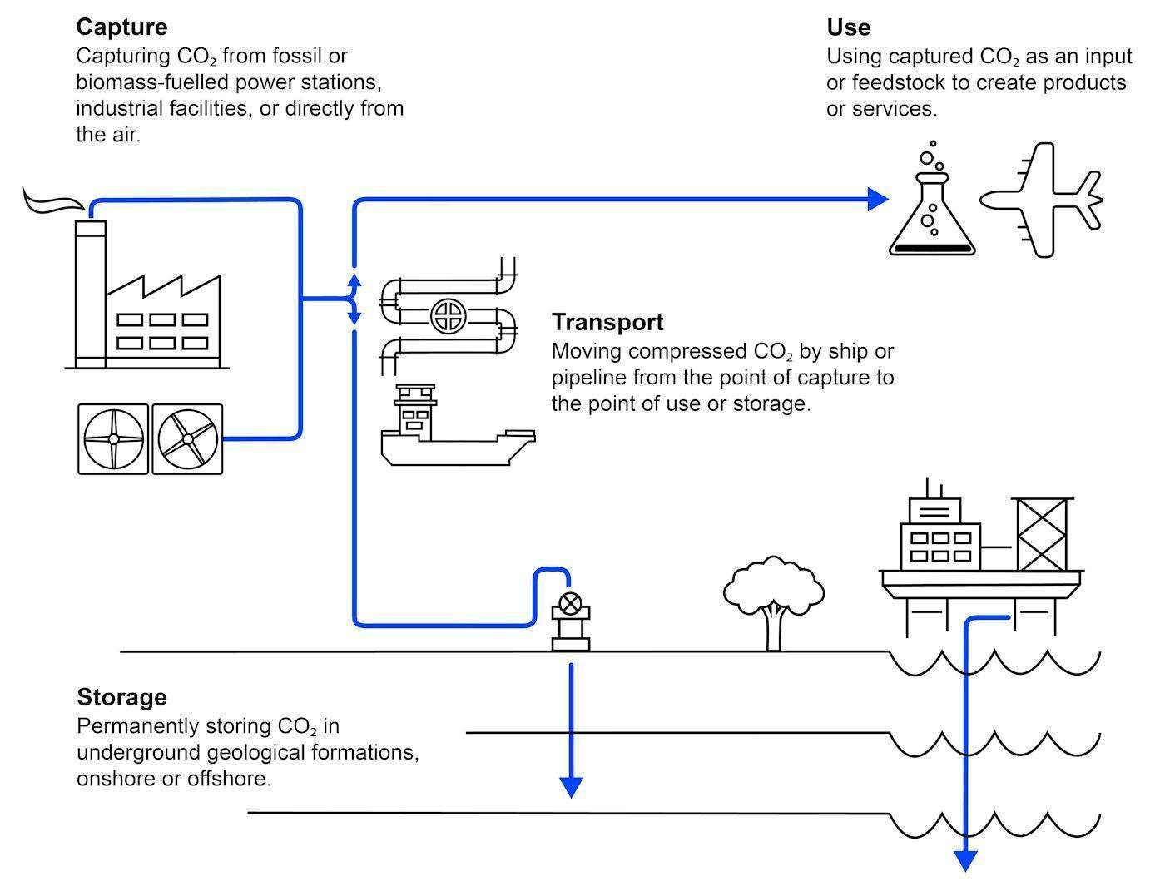
Source: International Energy Agency (2020)

To date, several CCUS projects around the world have been successful in implementing such technology to the point where it has been proven to reduce the amount of CO₂ emissions. Several of them showed promising results in offering valuable lessons, and potential for replications (Petra Nova Parish Holdings LLC, 2020). In the United States, the country owns facilities that achieve capture rates of 85-90%. This is supported by a stringent regulatory framework from United States agencies like the EPA, ensuring responsible implementation with minimal risks (Congressional Budget Office, 2023). The United States boasts an extensive pipeline network for CO₂ transport with over 5,000 miles in operation and no fatalities linked to its use (Righetti, 2017). Another notable CCUS project is the Texas collaborative initiative between NRG Energy and JX Nippon Oil, which captures approximately 90.2% of CO₂ emissions from coal-fired power plants (Jong et al., 2020). In the north, the Sleipner Project of Norway has injected 20 million tons of CO₂ since 1996 (Rimbono & Koestoer, 2023; Kazlou & Jewell, 2023). The Gorgon Project of Western Australia has successfully sequestered over 60 million tonnes of CO₂ since its inception (Kirchin & Petrie, 2022). Thus, CCUS should be viewed as a complementary strategy to renewable energy, particularly in sectors where alternative carbon reductions are limited (Kirchin & Petrie, 2022). Indonesia’s Pertamina is developing CCUS technology by using Enhanced Oil Recovery (EOR) techniques to improve reservoir performance (Akbar & Putro, 2024). Carbfix in Iceland employs mineral carbonation for long-term CO₂ storage, demonstrating cost-effective methods (Erol et al., 2023). Additionally, MCi Carbon in Australia is transforming CO₂ from heavy industries to valuable construction materials (MCi Carbon Leadership Team, 2024).
Despite the promising technological advancement that is capable of reducing and storing CO₂, there are many speculations, doubts, skepticisms, as well as opposition to CCUS technologies (Witte, 2023). Many laymen perceive CCUS as a potential barrier to achieving a carbon-free future, fearing that it may lead to an effect where the promotion of CCUS technologies diminishes governmental interest in reducing carbon-producing energy sources. This concern is due to the constant “greenwashing” from several stakeholders, who mistakenly viewed consumers as misled by several pseudo-sustainable solutions (Digmayer & Jakobs, 2017).
Several prominent environmental organizations globally and in Indonesia expressed their opposition to CCUS technologies due to significant risks. Food & Water Watch (FWW) argues that this technology is ineffective and only serves as a strategy for fossil fuel corporations to continue burning coal while claiming to mitigate carbon emissions, which is voiced by other organizations, particularly the Sierra Club (Food & Water Watch, 2023; Ahmed, 2023). Another argument against CCUS is that this project could result in a huge leakage, symbolizing the huge risk of overwhelming CO₂ emission in the air (Shaw et al., 2020). The scalability and unrealistic investments of CCUS technologies highlighted by Global Witness underscore the unalignment of the captured CO₂ with the amount of development funds for CCUS initiatives (Becker, 2023). This perspective is also echoed by TrendAsia through its collaborative report with the Centre for Research on Energy and Clean Air (CREA), which describes CCUS as the most uneconomical and a distraction from the transition to renewable energy as it contradicts the Indonesian government’s commitment to retire coal plants (TrendAsia, 2023). Whereas World Wildlife Fund (WWF), raises concerns about the feasibility and ecological impacts of CCUS technologies, pointing out the high costs and unintended risks that will outweigh climate benefits (World Wildlife Funds, 2021). One of the most notable oppositions was taken from a report by Greenpeace as they view it as a "false solution" that becomes a huge obstacle to renewable energy transition since this technology is being deemed as less clean with negative social impacts (Greenpeace, 2018).
As such, this research aims to analyze the negative narratives about CCUS technologies in mass media, the shaping of public opinion by activist groups, and to assess the extent to which these narratives align with scientific evidence. We aim to identify key themes in the negative messages directed at CCUS technologies, evaluate their impact on public perception, and determine whether the criticisms found in the media and activism are based on scientific facts or misconceptions. Through this conducted analysis, this research will contribute to a better understanding of the role in shaping the debate around CCUS technologies and provide insights for improving public communication to achieve better acceptance of CCUS technologies.

METHOD
This study employs a qualitative document analysis to examine the narratives surrounding CCUS technologies. The research is designed to systematically identify, analyze, and interpret the dominant arguments and frames used by environmental organizations and media outlets to shape public perception, particularly within the Indonesian context. This method is considered highly appropriate given the study's objective to understand how public discourse is constructed through existing texts and media artifacts.
The data were collected using a purposive sampling strategy, focusing on documents that play a significant role in shaping the public debate on CCUS. The corpus consists of two main types of documents. First, we selected official reports, position papers, and web publications issued by prominent international and Indonesian environmental organizations known for their critical stance on CCUS, including Food & Water Watch (FWW), Friends of the Earth International, Sierra Club, Global Witness, Greenpeace, and TrendAsia. All selected documents were published between 2018 and 2024 to ensure their relevance to current discussions. Second, to capture the specific discourse within Indonesia, we collected news articles from three major national online media outlets, such as CNN Indonesia, Kompas, and CNBC Indonesia. These articles were published between December 2023 and March 2024, coinciding with heightened public discussions around the presidential election. Search terms used during the data collection included “CCUS,” “penangkapan karbon,” “teknologi CCUS,” and “transisi energi.” From this process, we identified and selected approximately 15 organizational reports and 25 news articles for in-depth analysis based on their relevance and richness of narrative content related to CCUS.
The data were analyzed using a thematic analysis approach, which allowed for the identification, analysis, and reporting of patterns or themes within the data. The analysis was conducted through a structured, multi-stage process. Initially, all selected documents were read and re-read to gain a comprehensive understanding of the content. During this familiarization phase, we began generating initial codes by highlighting and labeling specific arguments, claims, and phrases related to CCUS, such as “high financial cost,” “risk of leakage,” “distraction from renewables,” and “greenwashing for fossil fuels.” These codes were then grouped into broader categories during the theme identification stage. For instance, codes such as “high cost” and “unrealistic investment” were classified under the overarching theme of “Economic Inviability.” In the final step, all themes were reviewed and refined to ensure they accurately captured the content and intent of the full dataset. This systematic approach allowed for a rigorous and transparent interpretation of the dominant negative narratives surrounding CCUS.

RESULT AND DISCUSSION
CCUS technologies are being opposed by several huge globally recognized environmental organizations. One of the reports is from Food & Water Watch (FWW). According to this organization, CCUS technologies are ineffective as they pose a significant public health risk as well as the environment. FWW asserts that carbon capture is essentially a strategy employed by giant fossil fuel corporations as an excuse to continue burning fossil fuels while claiming carbon mitigation efforts. This organization emphasizes that carbon capture allows conventional power plants to operate longer which of course, worsens the climate crisis. FWW highlights the Denbury pipeline incident that resulted in the release of CO₂, negatively impacting local residents. Furthermore, FWW claimed that such technology requires higher investments which means that there is a so-called concern toward the financial focus of renewable energy sources (Food & Water Watch, 2023).
According to Friends of Earth International, this organization claims that there are numerous challenges to carbon capture implementation, particularly BECCS. This organization highlights the energy penalty associated with the technology, the net amount of CO₂ that might be captured, adverse impacts, high costs, and risks of leakage (Shaw et al., 2020). This NGO spotlights how BECCS will deliver the consequences of a major leak during the capturing process, thus causing significant spikes in atmospheric CO₂ levels. Secondly, the organization viewed that the development of the BECCS project would open the door to corrupt carbon offsetting. This means that the NGO believes this technological development did not stop existing fossil fuel production and allow carbon offsetting which the organization is highly against (Cadena, 2019).
In the United States, one of the environmental organizations, Sierra Club, has strong resistance towards CCUS development in the country, saying that it serves as a means for fossil fuel industries to prolong their operations under the guise of sustainable responsibility. This organization argues that as the solution of CCUS technologies is to capture existing carbon, thus this would not stop polluting manufacturers, particularly the coal industry, from being responsible for the negative impact of its production of coal (Ahmed, 2023). Furthermore, the Sierra Club argues that there is a concern about CCUS development as several projects achieve only partial carbon capture rather than full reductions which means that there would not be an instant or fast result of carbon depletion (Robertson & Mousavian, 2022).
The argument for CCUS’ ineffectiveness is underlined by the insufficient support of scalability due to the unrealistic investment. As mentioned by an organization such as Global Witness, despite the cost of CCUS development that could reach up to $83 billion, it was noted that the captured CO₂ from CCUS technology is only less than 0.1% of the global CO₂ emissions in the year 2022, with over 80% of proposed projects failed to materialize. Global Witness also perceives that CCUS projects are the excuse of fossil fuel stakeholders to ensure the survivability of their operations, hindering the ideal proposition of stopping those industries from producing more unsustainable sources of energy (Becker, 2023).
One of the youth-led non-governmental organizations (NGOs) in Indonesia published a paper that emphasizes the critiques of CCUS on several fronts. Firstly, the NGO describes CCUS as uneconomical and a distraction for the power sector, emphasizing that the technology is largely unavailable commercially and costly to implement for power projects, especially when compared to other renewable energy sources. The financial burden is due to the fact that it is claimed how energy-intensive the CCUS is. The NGO argues that there is a plan for CCUS and coal power plant integration. It is claimed that the reliance on CCUS is seen as contradictory to the Indonesian government’s commitments to retire coal power plants (TrendAsia, 2023).
The critiques of CCUS are also highlighted by the World Wildlife Fund (WWF) where there is a concern regarding the feasibility and potential impacts. WWF itself emphasizes that while the technologies, particularly Bioenergy with Carbon Capture and Storage (BECCS) as well as Direct Air Capture (DAC) offer potential for CO₂ removal, they come with significant costs of limitations and risks BECCS is noted to be land-intensive and limited in the suitability of space. Thus it raises concerns about the ecological impact and opportunity costs associated with the conversion of land. Similarly with DAC despite the potential, WWF believes that the DAC method requires higher costs and usage of energy, which could limit the scalability and practical application. WWF points out that many proposed CCUS approaches carry high risks of unintended and damaging side effects on ecosystems, which outweigh the potential climate benefits (World Wildlife Funds, 2021).
Greenpeace, the giant environmental organization that is famous for being critical of several sustainable technologies, argues that CCUS technologies are extremely insufficient to address the urgent climate crisis. Greenpeace asserts that the earliest deployment of CCUS technologies at a significant scale is not expected before 2030, which is too late to avoid the negative effects of climate change. One of its primary criticisms is how the technology is energy-intensive, consuming between 10% and 40% of the energy produced by a power station. The significant amount of energy usage undermines the efficiency gains over the past decades and increases resource consumption. Furthermore, Greenpeace highlights the risks of storing CO₂ underground, noting the safety concerns (Greenpeace, 2018).
The financial cost also has been the reason for Greenpeace's disagreement towards CCUS. The financial burden of constructing the necessary infrastructure, combined with existing carbon pricing mechanisms, could lead to substantial increases in electricity prices. This economic consideration could deter the investment in this technology, which complicates the implementation. As such, Greenpeace ends up suggesting that financial allocations should be focused on renewable energy solutions, which have proven to be more effective in reducing emissions and providing sustainable energy (Greenpeace, 2018).
The Director of Greenpeace, Rex Weyler has stated in the 2022 report that there are 26 commercial carbon capture facilities globally that capture 40 million tonnes of CO₂ annually, which represents only 0.1% of the world's total emissions of 36.4 billion tonnes per year. The report mainly discusses several oil companies as it points out the continuation of oil production while receiving public subsidies. It argues that the industry has manipulated the concept of sustainability to create an illusion of reducing emissions while actually increasing them through more oil recovery techniques that utilize carbon capture technology. The failure of one of the carbon capture projects in Australia is being spotlighted in the report where it captures only a fraction of its emissions target (Weyler, 2022).
The Indonesian branch of Greenpeace has also criticized the planned initiative of CCUS technologies to be developed. This initiative was mentioned during the Indonesian presidential election and one of the Vice-Presidential candidates namely Gibran Rakabuming expressed the opportunity of CCUS technologies within Indonesia. Iqbal Damanik, a campaigner of Greenpeace Indonesia argues that CCUS technologies are not suitable for Indonesia and suggests a more plantation of forests and peatlands provision to capture carbon (Far, 2023). Many Indonesian news narratives highlight CCUS weaknesses, particularly from CNN Indonesia. The news highlighted Greenpeace Indonesia's stance on the ineffectiveness of implementing CCUS technologies in mitigating climate change in Indonesia. CNN Indonesia highlights Iqbal Damanik's view towards the development and concludes how it shows the potential dangers of transporting gases, including the risks of leaks or explosions (Far, 2023). The exposure of CCUS based on the presidential debate was also shown in other news sources such as CNBC Indonesia, Kompas, etc.
To conclude, critics of CCUS technologies, including major environmental organizations and media, argue that these systems are costly, risky, and largely ineffective in addressing climate change. They highlight that CCUS technologies allow fossil fuel industries to continue operating while claiming to be sustainable while contributing minimally to global carbon reduction. Concerns focus on scalability, energy intensity, risks of CO₂ leakage, and land-use conflicts, alongside the financial burden that could hinder investment in renewable energy. These narratives underscore the belief that prioritizing renewables offers a more direct and effective path to mitigating climate impacts.

Development, Research Efforts, and Milestones of CCUS Technologies
The fact that CCUS technologies are considerably one of the solutions in eradicating greenhouse gases, this innovation brings even more benefits than dangerous environmental harm as claimed by several environmental groups. Those claims are being debunked by RPS (an environmental consultancy firm) which highlights that CCUS is a technology that has been successfully implemented since the early 1970s with over 200 million tonnes of CO₂ captured and stored globally. Despite the Gorgon challenges, the project has still managed to sequester over 6 million tonnes of CO₂ since its inception. CCUS technologies should be viewed as a complementary strategy alongside renewable energy investments, particularly in industries where alternative carbon reduction methods are limited. RPS noted that there should be a continuation of carbon capture projects worldwide as it is worth a try. The myths of CCUS are the ones that need to be countered through measured communication as well as an education strategy (Kirchin & Petrie, 2022).

Figure 2. Scheme of power generation and industrial sites with CCUS integration
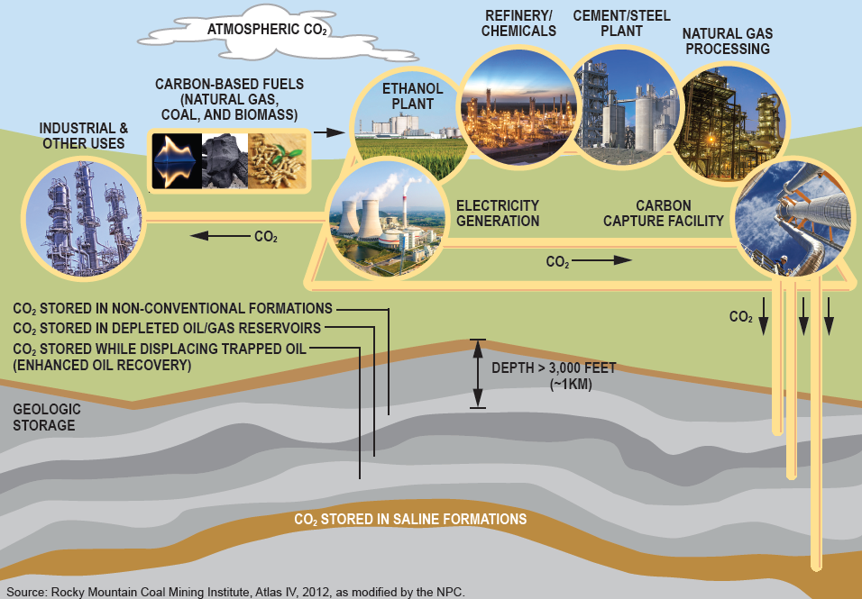
Source: Rocky Mountain Coal Mining Institute (2012)

As can be seen in Figure 2, the core of CCUS technologies is the capability to capture CO₂ emissions before being released into the atmosphere. Current facilities in the United States are capable of capturing between 85% to 90% of CO₂ emissions, with technological advancements suggesting that even higher capture rates are achievable. The safety of this technology is further reinforced by a stringent regulatory framework that governs the transport and storage of captured CO₂ (Congressional Budget Office, 2023). In the United States, federal oversight is provided by agencies such as the Environmental Protection Agency (EPA) and the Pipeline and Hazardous Materials Safety Administration (PHMSA). These agencies establish safety standards for CO₂ pipelines and storage sites, ensuring that the technology is implemented responsibly with fewer public health and environmental risks. The regulations require comprehensive risk assessments, monitoring, and reporting, which are essential for maintaining the integrity of storage sites and potential leak prevention (Harasaki & Riedl, 2024).
Another significant positive aspect of CCUS is the integration with well-innovated technologies that have been safely implemented for over four decades, particularly with the transportation of CO₂ through pipelines (Righetti, 2017). The long history of safe operation is underscored by the impressive record notably the CO₂ pipeline in the United States that has been transporting CO₂ for over 50 years. There have been no fatalities linked to the transportation of CO₂ via its pipelines. Furthermore, the United States owns the most extensive pipeline network in the world, with over 5,000 miles of pipelines in operation, primarily for enhanced oil recovery (EOR) operations. Moreover, CCUS technology offers diverse transport options via rail, truck, rail, ship, and barge. Thus, providing logistic flexibility and enabling the diversity of transportation tailored to regional needs. The existing infrastructure not only facilitates CO₂ transport but also demonstrates the economic viability of such projects, as transporting it via pipelines is the most cost-effective method due to economies of scale (National Petroleum Council, 2021).
On top of the established infrastructure, there is a growing interest in government support for CCUS initiatives. Recent discussions within the United States Congress indicate a willingness to provide financial backing for the CO₂ transportation infrastructure construction which reflects a favorable policy environment for CCUS technology advancement. The benefits of this technology are also substantial, as it plays a vital role in greenhouse gas emissions, which is very necessary to meet global climate goals and stabilize atmospheric CO₂ concentrations (Congressional Budget Office, 2023).
The potential for the industrial usage of captured CO₂ further enhances the appeal of CCUS technology, as it can be utilized in various applications such as alternative fuels, chemicals, beverages, construction materials, etc., contributing to the reduction of fossil fuel reliance (IEA, 2019). The captured CO₂ also can be directly injected underground in the geological formations. The geological storage for CO₂ is conducted in carefully selected formations that have been thoroughly evaluated for their stability and capacity to contain the gas over the long term. These formations, often located deep underground, are chosen based on their geological characteristics, which include impermeable rock layers that prevent the migration of CO₂. These storage sites' safety is continuously being monitored to detect changes that could indicate risks, thereby ensuring the security of stored CO₂ remains. The current ongoing CCUS technology research also plays a critical role in enhancing technological safety. Many scientists are continuously studying the long-term effect of CCUS including the potential seismicity and the behavior of CO₂ in geological formations over time (Congressional Budget Office, 2023).
To further illustrate the effectiveness and practicality of CCUS, several projects worldwide have demonstrated its success in capturing, utilizing, and storing CO₂ emissions while contributing to global climate goals. Firstly, a project located in Texas, USA is one of the most successful CCUS projects which was launched in 2017 in a collaboration between NRG Energy and JX Nippon Oil. This project successfully captures approximately 90.2% of the CO₂ emissions from a coal-fired power plant and also demonstrates the potential for integrating systems into existing energy infrastructure (Jong et al., 2020).
The Sleipner Project, operated by a company called Statoil located in the North Sea around Norway, is a pioneering initiative in CCUS technology. It is recognized as the very first commercial-scale project dedicated to geological CO₂ storage in a saline formation. Since its establishment in October 1996, the Sleipner project has successfully separated 9% of CO₂ from the produced natural gas at the Sleipner West Gas Field, which injected over 7 million tonnes of CO₂ into a saline aquifer located about 800 meters below the seabed (Rimbono & Koestoer, 2023). This means that the project has the annual removal of around 1 million tonnes of CO₂, with a total of 20 million tonnes expected to be stored over the project’s lifetime (Kazlou & Jewell, 2024).
Within Western Australia territory, a successful CCUS project was established in 2003. This CCUS initiative was one of the world’s largest CO₂ injection systems, integral to the Gorgon LNG Project on Barrow Island. This project has progressed through phases including concept selection, and detailed design, culminating in the commencement of injection operations in 2019 (IPCC, 2021). The Gorgon CCUS project is designed to inject approximately 3.5 million tonnes of CO₂ annually. By early 2021, over four million tonnes of CO₂ have already been injected, demonstrating the project’s capacity to manage and sequester greenhouse gas emissions. This project is expected to operate for over 40 years (Marshall, 2022).
Pertamina is the only Indonesia’s state-leading energy company that is actively developing carbon capture technology as part of its commitment to achieve Indonesia’s Net Zero Emission target by 2060 (Akbar & Putro, 2024). One of Pertamina’s initiatives includes CO₂ injection at the Pertamina EP Jatibarang Field in West Java, utilizing Enhanced Oil Recovery (EOR) techniques to improve reservoir performance. Pertamina plans to expand these projects to the Sukowati field in East Java, which will serve as a potential CO₂ storage site. Pertamina positions itself as a key player in establishing Indonesia as a carbon capture hub in the ASEAN region, leveraging the country’s abundant natural resources and sedimentary basins that could potentially store up to 400 gigatons of CO₂ (Hartono, 2023).
Carbfix, which is the carbon capture project from Iceland has made significant contributions to Carbon Capture and Sequestration (CCS) through mineral carbonation in basalt formations. Their approach involves injecting CO₂ into basalt rock formations, where it reacts with minerals to form stable carbonate minerals, thus mimicking natural weathering processes. This method provides a long-term storage of CO₂, thus reducing atmospheric greenhouse gases. The project is located at the Hellisheidi Geothermal Power Plant in Iceland and has demonstrated the feasibility of CO₂ mineralization. The most standout feature of Carbfix’s carbon capture project is its cost efficiency. It is shown that the costs associated with their pilot program range from €12.5 to €502.7 per ton of CO₂ stored, depending on the scale and efficiency of the operation (Erol et al., 2023).
MCi Carbon, one of the carbon capture companies in Australia has made significant achievements in its project. This company has developed a technology that transforms CO₂ from heavy industries into valuable materials made for construction materials, thereby supporting Australia’s transition to a circular economy. This company’s Myrtle CCU Demonstration plant commissioned in late 2024, aimed to capture 1,000 tons of CO₂ annually and produce low-carbon materials (MCi Carbon Leadership Team, 2024).
These successful CCUS projects highlight that this technology plays a critical role in mitigating climate change and in addressing the current carbon cycle imbalance caused by excessive anthropogenic CO₂ emissions. In a healthy carbon cycle, natural processes absorb CO₂ through plants, oceans, and soil, while releasing it back into the atmosphere in a sustainable way. However, the excessive carbon emissions from industrial processes, power generation, and transportation have overwhelmed these natural sinks, causing an imbalance that accelerates climate change. CCUS technology helps to rebalance this cycle by capturing CO₂ before it can contribute to further climate change. Importantly, CCUS is not limited to fossil fuel industries (as can be seen from several successful CCUS projects mentioned above); its applications span a variety of sectors, from geothermal energy to manufacturing, demonstrating its versatility and necessity. While the ultimate goal is a complete transition to renewable energy, this is a gradual process that requires time and infrastructure development. In the interim, existing fossil fuel-based power generation and other carbon-intensive industries urgently need solutions like CCUS to mitigate emissions. As such, every available effort must be made to accelerate the deployment of CCUS technology globally, ensuring that it complements renewable energy investments and contributes to meeting climate goals.

Public Perception of CCUS Technologies
Research conducted by Fraunhofer Alberto Sanchez utilized a combination of traditional surveys and social media analysis to collect comprehensive public attitudes toward CCUS technologies in Europe. The methodology of his survey involved scraping tweets related to CCUS, which were then categorized based on sentiments and concerns. A total of 3,374 tweets were collected and analyzed, focusing on perceived benefits and concerns associated with CCUS. The data of the survey as shown in Figure 3 indicates that 50% hold a negative opinion towards CCUS, suggesting a prevalent skepticism or concerns. However, only 30% expressed a welcoming view which showed a positive support towards the technology. 20% of the respondents were shown to have a lack of knowledge as well as awareness of the existence of CCUS technologies (Sánchez, 2023).
The findings exposed that a significant portion of survey respondents have no opinion on CCUS, while social media data indicated a predominance of negative sentiments. Most of the social media users labeled CCUS as either a scam, a waste of time, or greenwashing. The findings suggest that public engagement and education are crucial for the successful implementation of CCUS. It advocates for the development of targeted educational materials to address public misconceptions and enhance understanding of CCUS, thereby fostering a more informed dialogue about its role in mitigating climate change (Sánchez, 2023).

Figure 3. Public perception of CCUS technologies in Europe
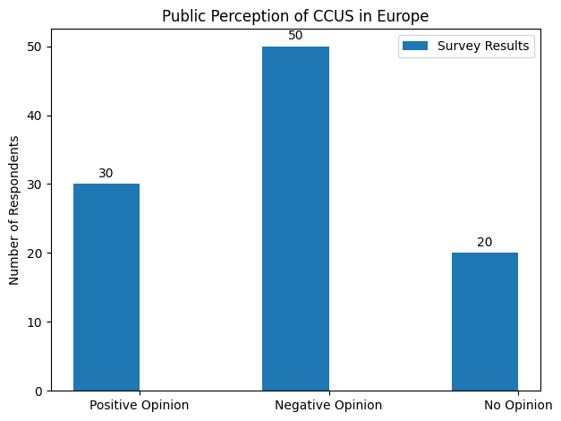
Source: Sánchez (2023)

There is research that highlights Indonesians' perception towards CCUS particularly in the greater Jakarta area (also known as JABODETABEK). The study surveyed 500 participants across five cities within the area, revealing a significant level of apprehension towards the technologies. Respondents expressed varying degrees of fear and interest as can be seen in Figure 3, which indicates that while there is a notable concern about the implications of CCUS, there is also curiosity about its potential benefits. This duplicity suggests that public education and effective communication strategies are important in alleviating fears and enhancing understanding of CCUS technologies (Sitinjak et al., 2023).
Additionally, the interesting point of this research is that demographic factors showed no differences in social acceptance scores across other aspects such as gender, income, age, and educational status, however, there is a notable difference between the perceptions of people within urban and rural residents, with urban residents demonstrating higher acceptance of CCUS technologies. This finding underscores the importance of targeted outreach particularly in rural areas to increase better acceptance and understanding of CCUS (Sitinjak et al., 2023).
The detailed results are explained below:
Based on the chart in Figure 4, a comparative analysis of public sentiment regarding CCUS technologies across five cities within the JABODETABEK area which consists of Jakarta, Bogor, Depok, Tangerang, and Bekasi was presented. The data is categorized into five levels of perception: Very Fear (High Fear), Poor Fear (Low Fear), Not Sure (Uncertain), Interest (Supportive), and Very Interesting (Highly Supportive). The analysis reveals significant regional differences in public attitudes, highlighting the complexities of engaging communities in discussions about CCUS technologies in five of those cities, especially within Indonesia as a whole.

Figure 4. Fear and interest levels among respondents in the JABODETABEK area
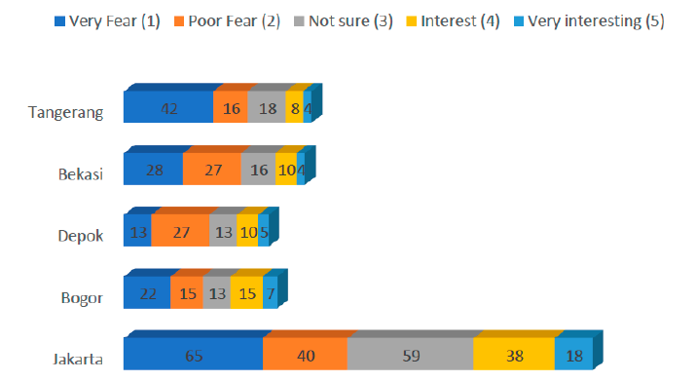
Source: Sitinjak et al. (2023)

Firstly, Tangerang is the city with a notable 42% of the respondents expressing a “Very Fear” of CCUS development as shown on the graph shown as the dark blue-colored bar. This indicates a strong apprehension that stems from a lack of understanding or misinformation about the technologies. Such a high level of fear is accompanied by a lower percentage in the “Interest” (8%) and “Very Interesting” (4%) categories, which show a more favorable or welcoming view towards CCUS. This suggests that efforts in educating and informing the Tangerang residents in shifting public perception from skepticism to favorableness towards CCUS technologies are urgently needed.
Bekasi however, presents a slightly more balanced view, with 28% of respondents leaning towards a “Very Fear” and a modest 10% of “Interest” welcoming towards CCUS, while 16% of the respondents are “Not Sure” of the positive or negative impact of CCUS, thus creating potentials for engagement through targeted communication strategies that can clarify misconceptions and provide information about the benefits and safety of CCUS development. This uncertainty could be leveraged to foster dialogue and increase awareness of CCUS technologies.
For Depok, a majority of the respondents disagree with CCUS with 13% of the respondents having a “Very Fear” and 27% of them showing a “Poor Fear”. Yet only 15% of the Depok residents present a welcoming view towards CCUS development (a total of “Interest” and “Very Interesting” respondents). Thus, this presents the urgency of better engagements with Depok residents to ensure the increase of welcoming view of CCUS technologies.
In Bogor, despite the high level of fear among all categories, it presents an even more balanced statistic. However, other categories are somewhat equal when it comes to the perception of technology among Bogor citizens. 15% of both “Poor Fear” and “Interest” indicate an equal or divided view among Bogor respondents towards CCUS technologies.
Finally, the capital city of Jakarta exhibits the largest number of extreme skepticism with the number of “Very Fear” (65%) with the addition of “Poor Fear” around 40%. It is very alarming considering Jakarta is a highly urbanized region where the population has better awareness towards environmentalism, making it a consideration for an extensive communication outreach towards Jakarta society to ensure a welcoming view towards CCUS technologies.
It can be said that the current public perception of CCUS technologies remains predominantly negative, largely due to being influenced by the prevailing narratives that emphasize skepticism and concern. The negative sentiment is compounded by the fact that the information reaching the public mostly focuses on the potential risks and drawbacks of CCUS, overshadowing its benefits and successful implementations. In addition, the explanations surrounding CCUS technologies are frequently articulated in technical terms that alienate the general public, making it challenging to grasp the public to ensure a better understanding of the technology. Thus, it is essential to develop clear, accessible communication strategies to combat the misunderstandings of CCUS technologies and highlight their role in addressing climate change.

Communication Engagement to Shape Welcoming Perception
Public engagement emerges as a cornerstone for the success of CCUS technological development, as public perceptions and attitudes guarantee significant influence on the project outcome. Effective communications become the very essential components of project management, necessitating not only the dissemination of information but also to addressing of public concerns. Thus, it fosters a sense of trust and collaboration between CCUS developers and the community. Actors involved in CCUS development need to consider how the project could impact the environment and society both in a positive and negative way. This study suggests that effective communication strategies that resonate or adapt to the mindset of the public need to be considered as this will make public reach out much simpler.
This study outlines how CCUS technologies are being misunderstood as the less effective solution to tackle climate change, which hinders further potential for innovative technological development. As such, this study provides several stronger strategies every stakeholder can implement to ensure more welcoming attitudes towards CCUS. The authors have analyzed several useful case studies of its development within Indonesia as well as how Indonesians think of CCUS implementation in the country. Reflecting on how the Indonesian public has very little awareness of such technology, many methods of communication, engagement, and outreach should be done in an appropriate manner depending on particular public behavior related to communications.
In Indonesia, one of the primary challenges despite the lack of awareness is skepticism. According to Sitinjak, low awareness and doubts are inter-connectable. Such correlation is evident since both involve a lack of understanding or clarity of a particular issue. It is to be noted that there is a likelihood of validity or importance towards something when the public lacks the information needed to form a clear and valid opinion. In this case, many individuals within Indonesia are afraid of the environmental and potential health risks associated with CCUS which could be an obstacle to development support (Sitinjak et al., 2023).
To address such barriers, it is extremely crucial to engage the Indonesian public through a participatory approach that prioritizes two-way dialogues to build trust. Implementing community discussions and other interactive forums could provide platforms for stakeholders to address public concerns directly, thus boosting understanding as well as acceptance of CCUS technologies (Mulyasari et al., 2021). Additionally, communication models to be implemented in outreach efforts play a bigger role in shaping public perceptions. Traditional communication methods which were only directed one way toward the audience were not as effective in highly engaging the public. Instead, a model that aligns with a two-way dialogue is recommended. Such an approach allows a stronger exchange of information where the concerns of the public can be addressed, thus encouraging the process of communication and feedback (Keane, 2018).
According to Keane, social media platforms are the most relevant in creating interactive dialogues, enabling every stakeholder to engage with the public and respond to their existing inquiries and concerns promptly. The framing and messaging of CCUS projects are critical components of effective communication strategies. Positive framing which emphasizes the benefits of CCUS such as jobs, economic opportunities, and environmental protection is the key to accumulating public support. In this context, positive framing is easily implemented in the modern method of communication which is digital media. With such a platform, stakeholders who develop CCUS could craft positive narratives based on which answer questions, doubts, and skepticism of the public (Keane, 2018).

Despite communicating the technological features of CCUS, it is important to consider other areas, particularly those that align with societal goals such as climate change mitigation and sustainable development. It is vital to deliver clear and relatable messages by using analogies and avoiding highly technical terminologies which can help create understandable information for the public. Transparency is one of the most undoubtedly inevitable in public outreach efforts, which means communicating potential risks and concerns is what should be done. If CCUS developers plan to establish education campaigns, they should include safety measures in case of several impacts of CCUS technologies. By being open about both the benefits and risks, stakeholders can foster a more informed public discourse around CCUS, which is essential for gaining acceptance (Bellamy & Raimi, 2023).
Engaging local stakeholders in the discussion of CCUS can further mitigate fears and enhance public support of the technology. It is essential for CCUS developers to have intense and frequent communications with them such as community members, local governments, and businesses. This could enhance trust as there is transparency in community engagements and there is a guarantee of more streamlined CCUS operations. Additionally, engaging with local stakeholders allows for a better understanding of the specific social, economic, and environmental contexts in which CCUS projects will be implemented (Sidiyanto et al., 2024). Local stakeholders often possess valuable insights and knowledge about the region including its history, culture, and environmental conditions. By involving those stakeholders in the decision-making process, CCUS developers can benefit from local knowledge, which could enhance the effectiveness and sustained environmental and social protection efforts of every CCUS initiative. Engaging local communities also provides better opportunities to address any concerns or misconceptions about CCUS technologies. Open discussion can help in clarifying the benefits and risks associated with CCUS, thus dispelling myths and fostering more informed public opinion (Seigo et al., 2014).
It is necessary to tailor communication strategies to the specific socio-economic and cultural contexts of communities particularly within Indonesia. The most important deliberation is to understand local values, beliefs, and concerns which can help in designing effective outreach programs that resonate with the public depending on the region. As an example, utilizing local media and community resources can enhance the visibility and acceptance of CCUS technologies, making them relatable to the public (Nielsen et al., 2022).
To successfully implement a stronger positive sentiment of CCUS technologies, research from Midwest Regional Carbon Initiatives (MRCI) formulated three phases. By these phases, MRCI experienced a steady increase in public engagement where their message resonates well with the hearts and minds of their target audience within the Midwest region of the United States. Firstly, MRCI executed the Planning Phase where they undertook extensive research to prepare for effective outreach. MRCI identifies segmented target audiences, conducts stakeholder mapping, and develops tailored communication materials that resonate with the specific concerns of different groups. MRCI ensures that the messaging is not only clear and informative, but also strategically aligned with the goals of promoting CCUS technologies. Such preparatory work is crucial in addressing the diverse perspectives and potential skepticism surrounding CCUS, particularly in regions with varying social landscapes (Collins et al., 2022).
The second phase which is known as the Active Phase is the implementation of the communication strategy, where the MRCI directly engages with its targeted audience through a variety of channels. This includes community events, conference participation, and utilizing digital platforms such as podcasts to facilitate discussions about CCUS. During this phase, the initiative actively disseminates information, shares success stories, and addresses public concerns, hence enhancing a dialogue that encourages community support and involvement. Their commitment to transparency and engagement is essential for trust-building and countering misinformation about CCUS (Collins et al., 2022).
The Maintain and Sustain Phase focuses on the long-term engagement of stakeholders as well as the continuous updating of communication materials. In this phase, the MRCI seeks to nurture relations with community leaders and stakeholders, ensuring that their concerns and feedback are integrated into ongoing communication efforts. This engagement, which is being done in a sustained manner, is vital for maintaining public interest and support for CCUS initiatives. By keeping communication channels open and relevant, the MRCI aims to create a lasting impact that supports the successful implementation of CCUS technologies in the region (Collins et al., 2022).
It is to be noted that the implementation of effective communication strategies can be leveraged through the usage of social media. Taken from the example of electric vehicle (EV) manufacturers such as BYD. CCUS stakeholders within Indonesia can adopt BYD’s strategic approach by focusing on technological innovation, sustainability messaging, as well as community engagement. Firstly, it is important for CCUS initiators to prioritize research and development to create more advanced carbon capture technologies that are scalable for various industrial applications (Adam et al., 2024). By investing in cutting-edge solutions, CCUS stakeholders can enhance operational effectiveness. With such considerations, this will simplify and strengthen information dissemination as CCUS developers can craft marketing campaigns that clearly communicate the environmental benefits of their technologies, emphasizing how CCUS can significantly reduce greenhouse gas emissions and contribute to climate change mitigation. This messaging should be supported by educational content that demystifies CCUS processes for the public, thereby fostering a better understanding and acceptance of these technologies.
Similar to BYD, CCUS stakeholders should engage with local communities in raising awareness about the importance of carbon capture technologies and their crucial role in reducing carbon emissions. This can be achieved through workshops, seminars, and partnerships with environmental organizations. When it comes to social media utilization, CCUS initiators could implement BYD’s use of digital marketing to connect with its audience (Adam et al., 2024). They can also focus on creating compelling visual content that highlights the effectiveness and benefits of carbon capture technologies. This could include infographics that explain the CCUS process, interactive videos showcasing successful projects, and comparisons that demonstrate the environmental impact after the implementation of CCUS technology (Nugroho & Harjanto, 2023). CCUS stakeholders can foster community interaction by encouraging discussions around sustainability topics, responding to audience inquiries, and creating interactive content such as polls or quizzes that educate the public about overall CCUS technologies. By building a strong online presence and engaging with their audience in a meaningful way, they can effectively raise awareness of their technologies and promote a broader understanding of their role in combating the risks of climate change (Rohadian & Amir, 2019).
To further enhance the discussion on CCUS public engagement, it is extremely essential to consider the role of education and capacity building in fostering a supportive environment for the initiatives. As such, CCUS developers could incorporate educational initiatives that target various demographics within the Indonesian population (Mulyasari, 2024). Tailored educational programs can be designed to address the specific knowledge gaps and misconceptions prevalent in different age groups, professions, as well as educational backgrounds. It is suggested that CCUS developers could enhance collaborations with schools and universities thereby bringing up the topic of CCUS technologies. By investing in education, CCUS initiators can cultivate a more knowledgeable public that is better equipped to discuss CCUS and its implications for the environment and economy.
Furthermore, leveraging partnerships with local NGOs are thing that CCUS developers should not overlook. These organizations often have established trust and rapport within communities, making them the most valuable allies in disseminating information about CCUS technologies (Mulyasari, 2024). Initiating collaboration with these groups can facilitate grassroots campaigns that connect with local values and concerns, ensuring that the messages are culturally and socially relevant and impactful. Not only that involving local NGOs is a must, but partnering with local leaders in these initiatives can help to further legitimize the conversation around CCUS, as their endorsement can sway public opinion and encourage community participation.
To sum up, public engagement is pivotal for the success of CCUS technologies, as public perceptions and attitudes significantly influence project outcomes. This study shows the need for effective communication strategies that go beyond information dissemination to actively address public concerns, foster trust, and promote collaboration. A key challenge, particularly in Indonesia, is the public's low awareness and skepticism towards CCUS, driven by fears of environmental and health risks. Addressing these issues requires a participatory approach that prioritizes two-way dialogues, transparency, and locally tailored outreach methods. Moreover, educational initiatives targeting various demographics and partnerships with local stakeholders and NGOs are critical in building a knowledgeable and supportive public. Ultimately, well-designed communication strategies are essential to dispel misconceptions, align CCUS efforts with societal goals, and secure public acceptance, ensuring the technology’s successful implementation and its contribution to climate change mitigation.

CONCLUSION
Effective communication strategies are essential for reshaping public perceptions of CCUS technologies in Indonesia. Despite the significant potential of CCUS to mitigate climate change by capturing and repurposing carbon emissions, public skepticism remains high, largely due to misinformation and negative portrayals. Many Indonesians express fears regarding the safety and efficacy of the technology, mostly influenced by narratives from several environmental organizations and media outlets.
As such, to address these challenges, a multifaceted approach to communication effort is necessary. This includes educational initiatives aimed at demystifying CCUS technologies and clarifying the strengths and benefits. Engaging local communities through partnerships with organizations and leveraging social media platforms for interactive dialogue are crucial strategies to foster trust and understanding. It is important to frame CCUS positively, emphasizing its role in economic opportunities, job creation, and environmental protection to combat the prevailing negative narratives.
This study highlights that communication framing plays a central role in influencing public acceptance of CCUS technologies. How CCUS is portrayed, whether as a risky extension of the fossil fuel industry or as a climate solution, significantly shapes public attitudes. Therefore, framing should not be treated as a peripheral issue, but as a core component of communication strategy and policy design.
Ultimately, improving public awareness and acceptance of CCUS is vital for its successful implementation in Indonesia. By prioritizing transparent communication and community engagement, stakeholders can help shift the narrative from skepticism to support, paving the way for CCUS technologies to play significant roles in climate change mitigation efforts.
However, this study is limited by its reliance on secondary data and document analysis, which may not fully capture the range of public perceptions or the evolving nature of discourse in real time. Future research could benefit from incorporating empirical data such as surveys, interviews, or focus group discussions to explore the attitudes of different stakeholder groups more comprehensively. In addition, comparative studies across different regions or countries could provide insights into how cultural, political, and media contexts influence the perception and acceptance of CCUS technologies.

REFERENCES
Adam, B. M., Berto, A. R., & Haryanto, I. (2024). Engaging early consumers: How BYD leads EV diffusion in Indonesia. Communicare: Journal for Communication Studies, 11(2).
Ahmed, A. (2023, October 11). Carbon capture and storage at fossil plants is promoted as a needed climate solution. https://www.sierraclub.org/sierra/carbon-capture-and-storage-fossil-plants-promoted-needed-climate-solution
Akbar, I., & Putro, U. S. (2024). SAF implementation in 2027: A case study of Indonesia. European Journal of Business & Management Research, 9(5).
Becker, S. B. (2023, November 17). What is carbon capture and storage? CCS easily explained. https://www.globalwitness.org/en/blog/what-carbon-capture-and-storage-ccs-easily-explained/
Bellamy, R., & Raimi, K. T. (2023). Communicating carbon removal. Frontiers in Climate.
Cadena, L. (2019). Carbon markets at COP25, Madrid: A threat to people, politics, and planet.
Collins, J. F., Greenberg, S., Gupta, N., Haagsma, A., Hawkins, J., & Sung, J. (2022, October). A case study: Strategic CCUS communications across a 20-state region of the United States. In Proceedings of the 16th International Conference on Greenhouse Gas Control Technologies (GHGT-16).
Congressional Budget Office. (2023). Carbon capture and storage in the United States.
Digmayer, C., & Jakobs, E.-M. (2017, July). Sustainability or eco fraud? Perception and communication of carbon capture and usage. In Proceedings of the IEEE International Professional Communication Conference.
Dwivedi, Y. K., Hughes, L., Kar, A. K., Baabdullah, A. M., & Grover, P. S. (2022). Climate change and COP26: Are digital technologies and information management part of the problem or the solution? An editorial reflection and call to action. International Journal of Information Management.
Eberenz, S., Dallo, I., Marti, M., Becattini, V., Holenstein, M., Weimer, S., & Mazzotti, M. (2024). Nine recommendations for engaging with the public and stakeholders for carbon capture, transportation, utilization, and storage. Energy Research & Social Science.
Erol, S., Akin, T., & Akin, S. (2023). Update for reactive transport modeling of the Kizildere geothermal field to reduce uncertainties in the early inspections. Turkish Journal of Earth Sciences, 32(4).
Far. (2023, December 23). Greenpeace: RI tak efektif pakai teknologi carbon capture & storage. CNN Indonesia. https://www.cnnindonesia.com/teknologi/20231223105747-199-1041072/greenpeace-ri-tak-efektif-pakai-teknologi-carbon-capture-storage
Food & Water Watch. (2023). Why carbon capture won't solve the climate crisis.
Greenpeace. (2018). False hope: Why carbon capture and storage won't save the climate.
Hanson, E., Nwakile, C., & Hammed, V. O. (2025). Carbon capture, utilization, and storage (CCUS) technologies: Evaluating the effectiveness of advanced CCUS solutions for reducing CO₂ emissions. Results in Surfaces and Interfaces, 18.
Harasaki, H., & Riedl, D. (2024, October 15). Regulating safety for carbon removal, capture and sequestration projects in the US. WRI Technical Perspectives. https://www.wri.org/technical-perspectives/regulating-DAC-CCS-safety
Hartono, T. T. (2023). Economic, social, and environmental impacts of the economic empowerment program in Gampong Kuta Barat, Sukakarya District, Sabang City, Aceh Province. Prospect: Jurnal Pemberdayaan Masyarakat, 2(3).
International Energy Agency. (2019). Putting CO₂ to use.
International Energy Agency. (2020). Energy technology perspectives 2020: Special report on carbon capture, utilization and storage.
IPCC. (2021, June). Carbon dioxide capture and storage: A route to net zero for power and industry.
Jong, J., Sin, G. H., McGiveron, S., & Fitton, J. (2020). A case study of natural gas hydrates (NGH) in offshore NW Sabah: Identification, shallow geohazard implication for exploration drilling, extraction challenges and potential energy resource estimation. Bulletin of the Geological Society of Malaysia, 70.
Kazlou, T., & Jewell, J. (2024). Feasible deployment of carbon capture and storage and the requirements of climate targets. Nature Climate Change.
Keane, R. (2018, October). Communication of scientific knowledge about carbon capture and storage (CCS) through social media (SM). In Proceedings of the 14th International Conference on Greenhouse Gas Control Technologies.
Kirchin, A., & Petrie, S. (2022). Common myths about carbon capture and storage.
Marshall, J. (2022). A social exploration of the West Australian Gorgon gas, carbon capture, and storage project. Clean Technologies.
MCi Carbon Leadership Team. (2024). Opportunities in the circular economy.
Mulyasari, F. (2024, September 27). Public engagement strategy for public acceptance and social license to operate for carbon capture (utilization) and storage project. Paper presented at the 17th Asia CCUS Network Knowledge Sharing Conference, Jakarta, Indonesia.
National Petroleum Council. (2021). Meeting the dual challenge: A roadmap to at-scale deployment of carbon capture, use, and storage.
Nielsen, J. A., Stavrianakis, K., & Morrison, Z. (2022). Community acceptance and social impacts of carbon capture, utilization and storage projects: A systematic meta-narrative literature review. PLOS ONE.
Nugroho, M., & Harjanto, R. (2023, January). Creating effective marketing communication strategy for electric car mass market appeal.
OGCI. (2024). Carbon capture and utilization as a decarbonization lever.
Petra Nova Parish Holdings LLC. (2020). W.A. Parish post-combustion CO₂ capture and sequestration demonstration project: Final scientific/technical report.
Righetti, T. (2017). Siting carbon dioxide pipelines. Oil and Gas, Natural Resources, and Energy Journal, 3(4).
Rimbono, R., & Koestoer, R. H. (2023). Briefed on the development and progress of CCUS projects in China, USA, Western Europe, Russia, Norway, India, and Indonesia: A journal review. Applied Environmental Science.
Robertson, B., & Mousavian, M. (2022). The carbon capture crux.
Rohadian, S., & Amir, M. T. (2019). Upaya membangun customer engagement melalui media sosial Instagram. Journal of Entrepreneurship, Management and Industry.
Sánchez, A. (2023). Exploring public perception on CCUS in Europe: A social media analysis approach.
Seigo, S. L., Dolhe, S., & Siegrist, M. (2014). Public perception of carbon capture and storage (CCS): A review. Renewable and Sustainable Energy Reviews.
Shaw, S., Marien, N., & Cadena, L. (2020). A leap in the dark: The dangers of bioenergy with carbon capture and storage (BECCS).
Sidiyanto, Y. A., Hussaini, J., & Sari, R. F. (2024). The pathway towards supporting the implementation of the new Indonesian law on carbon capture and storage in Indonesian universities. EDP Sciences.
Sitinjak, C., Ebennezer, S., & Ober, J. (2023). Exploring public attitudes and acceptance of CCUS technologies in JABODETABEK: A cross-sectional study. Energies.
Sodiq, A., Abdullatif, Y., Aissa, B., Ostovar, A., Nassar, N., El-Naas, M., & Amhamed, A. (2023). A review on progress made in direct air capture of CO₂. Environmental Technology & Innovation, 29.
Su, X., Liu, P., Mei, Y., & Qiu, J. (2024). The impact of carbon capture, utilization, and storage (CCUS) projects on environmental protection, economic development, and social equity. Journal of Cleaner Production.
Sule, R., Gunawan, A. W., Kadir, A., Matsuoka, T., Prabowo, H., & Sidemen, G. S. (2018, October). Gundih CCS pilot project: Current status of the first carbon capture and storage project in South and Southeast Asia regions. In Proceedings of the 14th International Conference on Greenhouse Gas Control Technologies.
TrendAsia. (2023). Ambiguities versus ambition: A review of Indonesia's energy transition policy.
Weyler, R. (2022). The great carbon capture scam.
Witte, K. (2023). Social acceptance of carbon capture and storage (CCS) from industrial applications. Sustainability.
World Wildlife Fund. (2021). WWF position paper: Carbon dioxide removal, including carbon sequestration in natural systems.

